# Admin

## 用戶管理

Once login with Admin role, DocTracker main page will show User Account Summary as below:

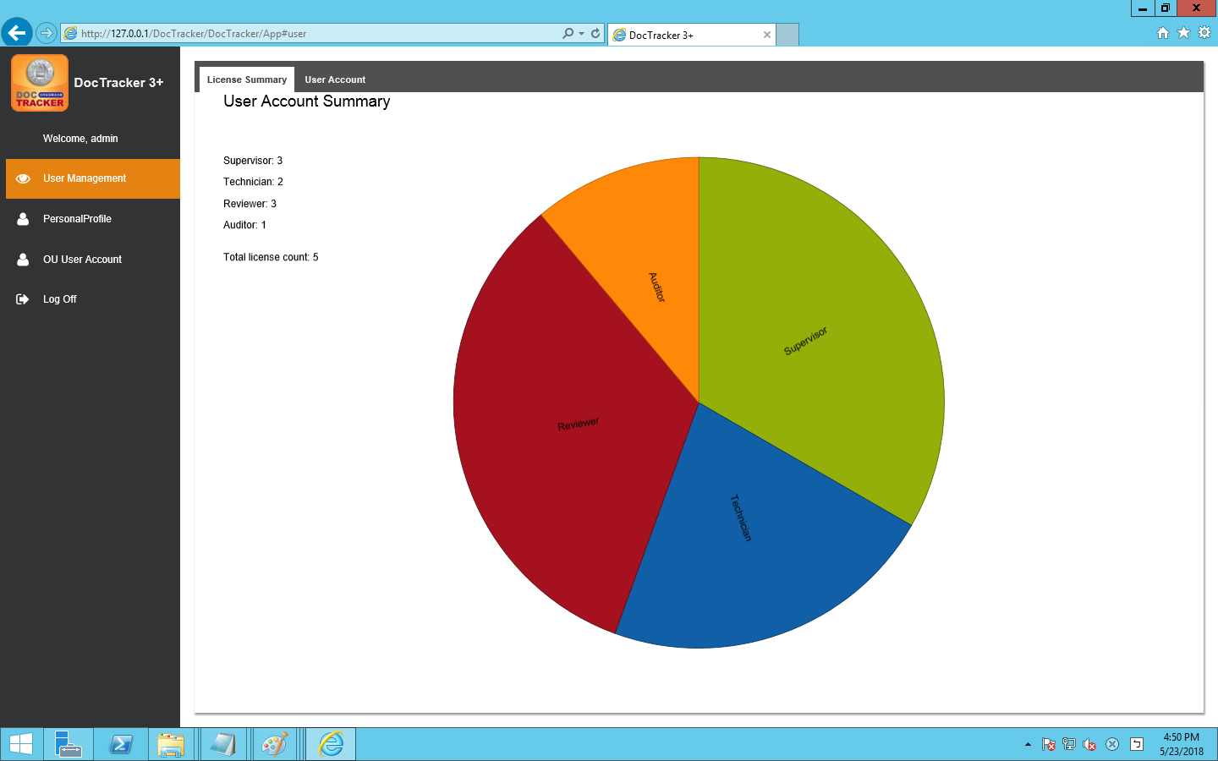

### 1.1 新增使用者

Before setting up and start using DocTracker, it is required to create users for different roles,, The Admin role can create an account for the (Supervisor, Technician) role, The Supervisor role can create an account for the (Auditor, Reviewer) role. After selecting [User Management] on the left menu then select the [User Account] tab on the right side, After press the button , the following message will appear:

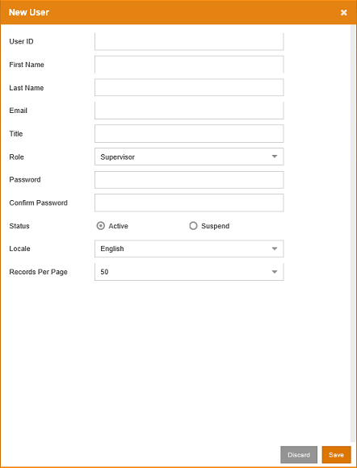

The function of each field and button are listed below:

|  |  |
| --- | --- |
| Field / Button | Description / Function |
| User ID | The unique Login ID for the user. |
| First Name | The first name of the user. |
| Last Name | The last name of the user. |
| Email | The email address of the user. |
| Title | The title of the user. This can be blanked. |
| Role | The Technician user has permission to setup the system. The Supervisor user has permission to create Reviewer and Auditor. |
| Password | The password for the user. |
| Confirm Password | Re-type the password for the user. |
| Status | The status of the user. “Active” enables the user to logon to the system. “Suspend” disables the user to access the system. |
| Locale | The language for the User Interface. It can be “English”, “Simplified Chinese” or “Traditional Chinese”. |
| Records Per Page | The number of records shown on each page. The value ranges from 10 to 60. |
|  | Press this button to leave this page without adding the user. |
|  | Press this button to create the user with the input information. |

### 1.2 Update User

To update the user properties, select the user and click the  button or double click the user to bring up the following update user screen:

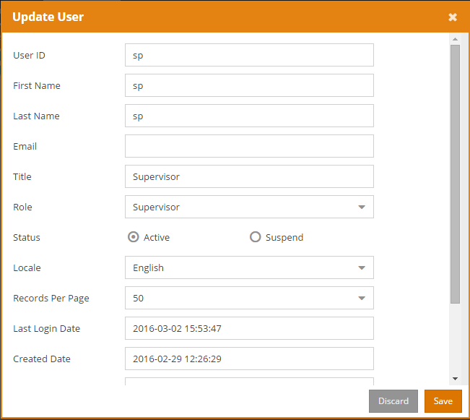

Once the modification is made, click the  button to save changes. Click the  button to exit the screen without saving.

### 1.3 Delete User

To delete a user, select the user and click the  button. A confirmation message will prompt the user to confirm the deletion of the user as below.

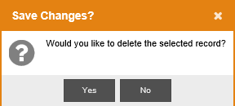

Click  to delete the user or click  to cancel the deletion.

### 1.4 Reset Password

To reset password of a specific user, select the user and click the  button to bring up the following Reset User Password screen:

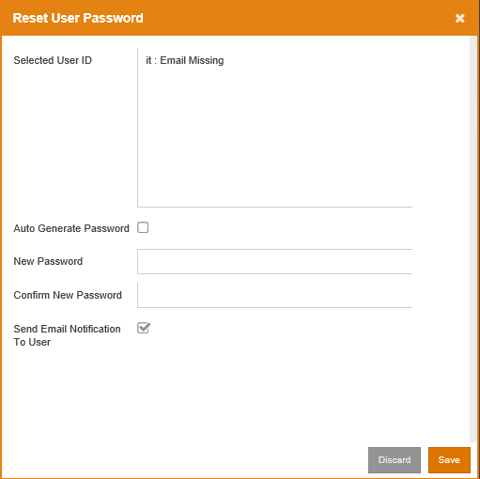

Click the  button to reset. Click the  button to exit the screen without resetting the password.

The following table describes the fields in the Reset User Password screen:

|  |  |
| --- | --- |
| Field | Description |
| Selected User ID | The user which is currently selected, and states if the user has an email address |
| Auto Generate Password | Auto generates a password and sends to this user via email. |
| New Password | Customize a password for this user. |
| Confirm New Password | Re-enter the password. |
| Send Email Notification To User | Specify whether to send email to this user. |

### 1.5 View Group (except MFP)

To view Access Map User Mapping for Access Map Permission, or to view AD OU Mapping for AD / OU Permission, click the  button to view the groups and their users.

## Personal Profile

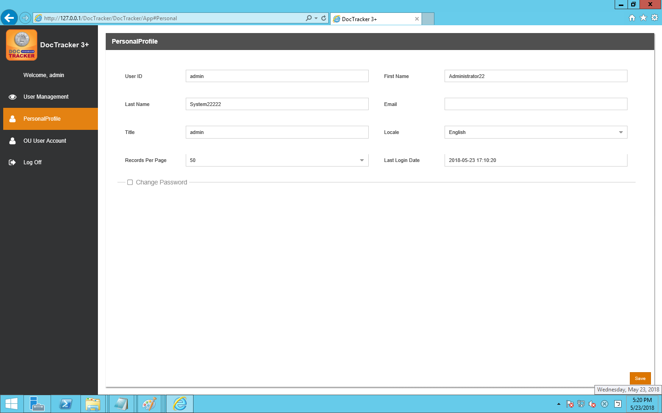

It shows user information about [User ID] [First Name] [Last Name] [Email] [Title] [Locale][Records Per Page][Last Login Date], language can be adjusted by [Locale].

In addition to the [User ID] can not be changed, other information can be changed

Press after change and a following message appears

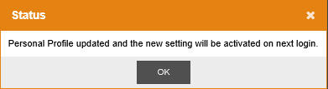

The new setting will take effect after the next login.

## OU User Account

This page is used to synchronize the Account from Active Directory(AD) Server to Doctracker System.

### AD Server

There are few things that should be noticed:

🡪 AD Server must be prepared.

🡪 OU is created(OU Name does not matter).

🡪 Inside the OU,4 Group must be added and the name must be specified(Auditor, Reviewer, SP, Tech)**.** And the groups contain the users.

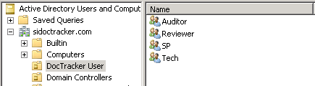

🡪 Do NOT tick 

When create or modify the user, it will block the login function from

DocTracker Server.

Before synchronizing account, configuration must be done on DocTracker Server.

### Sync Account Config

To configure information of server, press button and following screen show:

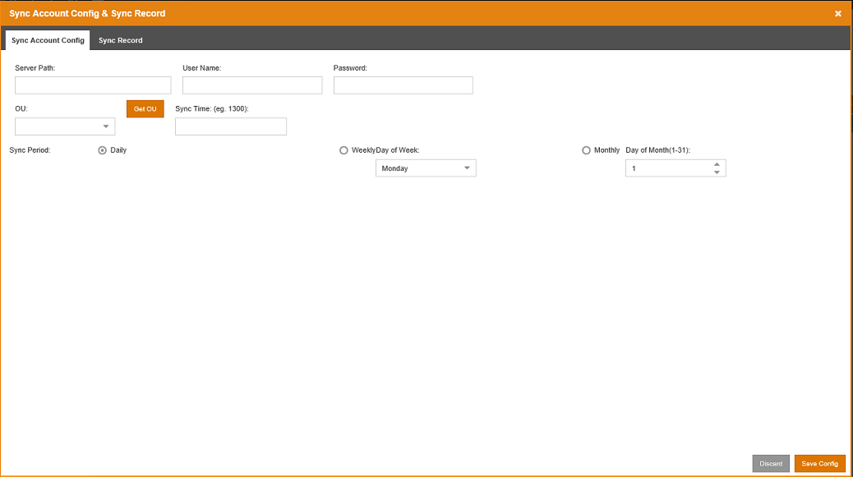

The following is a description of each noun:

|  |  |
| --- | --- |
| Field / Button | Description / Function |
| Server Path | AD server IP address |
| User Name | The username of the AD server. |
| Password | The user password of the AD server. |
| OU | The selected OU from the AD server |
|  | Obtaining the OU from the AD server |
| Sync Time | The time of the day to sync with the AD server |
| Sync Period | There are 3 type of sync period, daily, weekly, and monthly. |

Click the  button to save the changes. Click the  button to exit the screen without saving.

After save the configuration and exit the configuration page, user may click  to synchronize without waiting the setting time

### Sync Record

Record will be saved when the synchronize process is occurred.

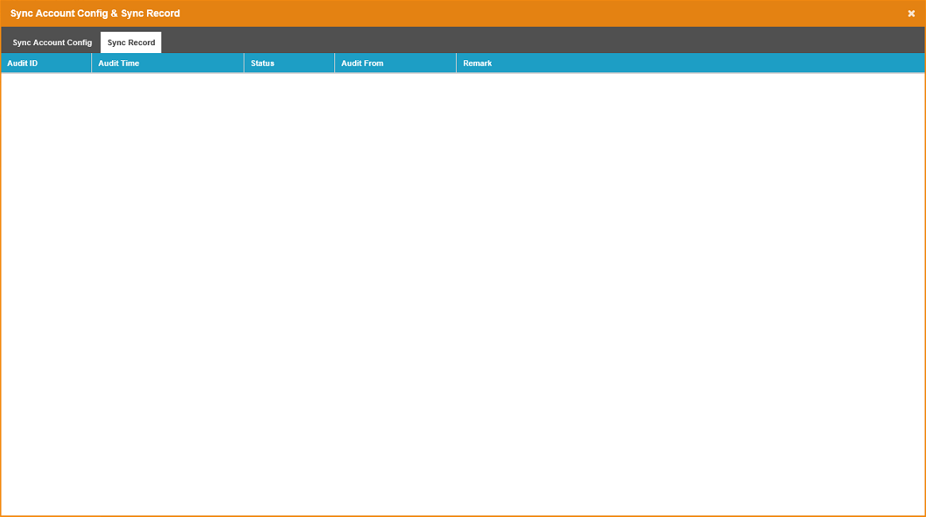

The meaning of column ‘REMARK’:

|  |  |
| --- | --- |
| Remark | Description |
| Total Account in OU | The total users of the 4 groups (Auditor, Reviewer, SP, Tech) on AD Server. |
| Total Existing Account | The total number of OU users on current DocTracker Server. |
| Created | The numbers of OU users are synchronized into DocTracker Server. |
| Updated | The number of existing OU users have updated on the DocTracker Server. |
| Bypassed | OU User(s) is/are conflicted with the local user on DocTracker Server. These users will skip the synchronization. |
| Deleted | The OU Users which are no longer existed on AD Server. These Users will delete from the DocTracker Server. |

# Technician

## OCR Station Management

To define OCR server, click OCR Station Management on the navigation bar, and the following screen will show. At the OCR Station Setting tab, Technician can define OCR Station ID, IP address, Port, and interval time, etc。

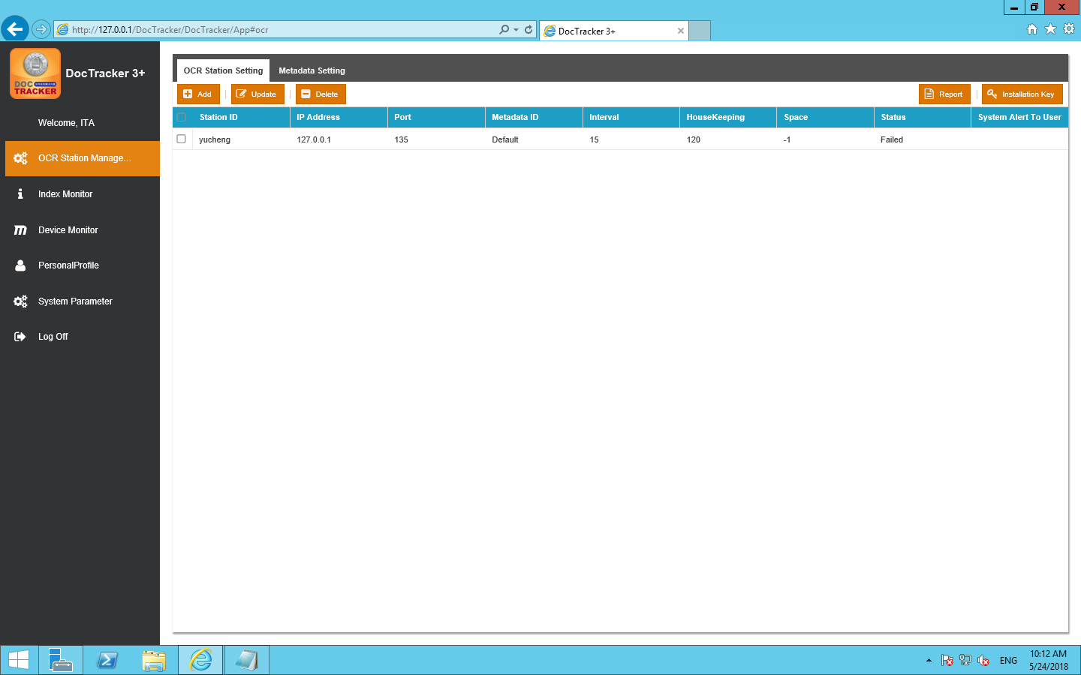

The functions of each field are listed below:

|  |  |
| --- | --- |
| Field / Button | Description / Function |
| Station ID | OCR server unique name |
| IP Address | OCR server IP address |
| Port | OCR server platform’s connection port |
| Metadata ID | Metadata to be used in the OCR server |
| Interval | The interval time (in minute) to monitor the specific folder for OCR server. |
| HouseKeeping | The time period (in month) to keep the information in the OCR server |
| Space | Available space (in GB) in OCR server |
| Status | The connection status between the DocTracker server and the OCR server |
| System Alert to User | If OCR server is disconnected, specified DocTracker user will receive an email notification |

### 1.1.1 Add OCR Station

To add a new OCR station, click the  button and the following screen will pop up:

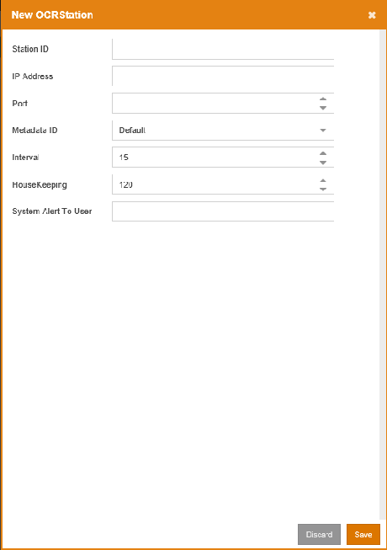c

### 1.1.2 Update OCR Station

To update any setting of an OCR server, select the OCR station and click the button or double click the OCR station to bring up the following update OCR station screen:

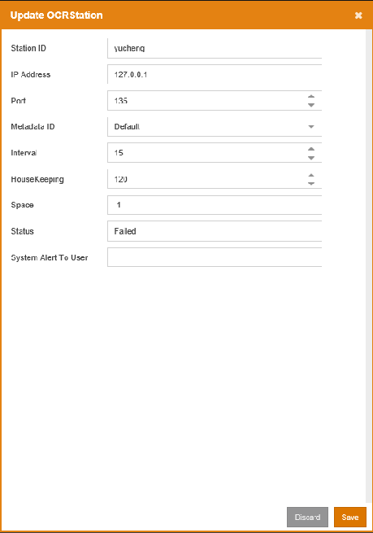

Once the modification is made, click the  button to save the changes. Click the  button to exit the screen without saving.

### 1.1.3 Delete OCR Station

To delete an OCR server, select the OCR server and click the  button. A confirmation message will prompt the user to confirm the deletion of the OCR server as below.

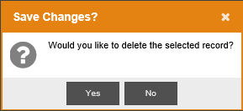

Click the  button to delete the OCR server or click the  button to cancel the deletion.

### 1.1.4 Export OCR Station Info

To export OCR station connection status and space alert report, click the  button, to generate a report in excel.

### 1.1.5 Generate Installation Key

After saving the OCR station setting, click the  button to generate the installation key, which is required when installing OCR server. If you change the OCR sever setting without generating and applying a new installation key, the connection between the DocTracker server and the OCR server may be affected.

## Index Monitor

The Index Monitor displays the indexing status. DocTracker is able to search documents’ content. If searching content is not functioning properly, click the  button to re-index all records. If there are some failed records which were unable to index, click the  button to re-index the failed records

## Device Monitor

The Device Monitor displays the number of printed documents, the number of copied documents, the number of scanned documents, and the number of faxed documents.

## Personal Profile

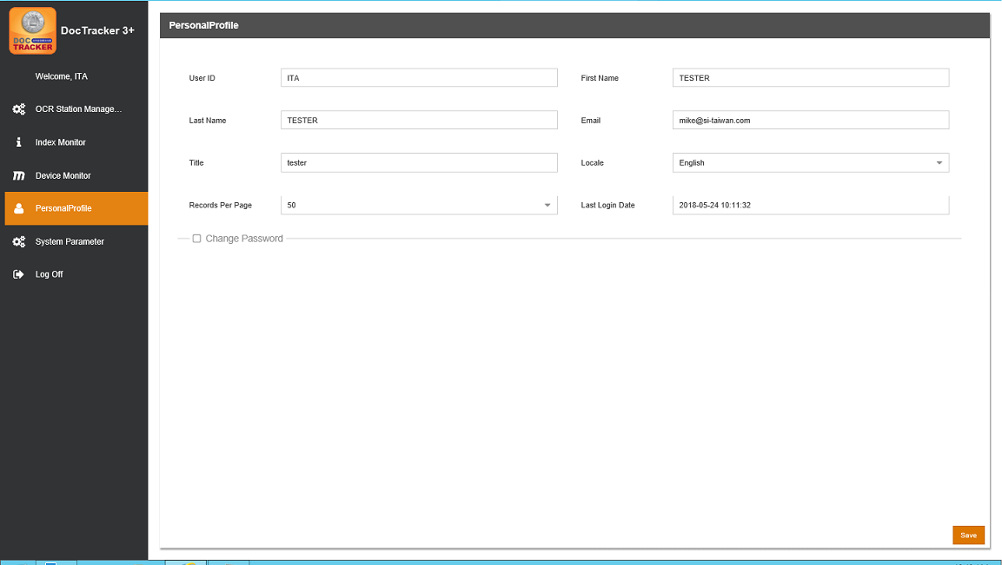

It shows user information about [User ID] [First Name] [Last Name] [Email] [Title] [Locale][Records Per Page][Last Login Date], language can be adjusted by [Locale].

In addition to the [User ID] can not be changed, other information can be changed

Press after change and a following message appears

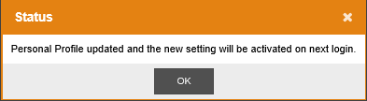

It means new settings will take effect after the next login

## System Parameter

Once login, DocTracker main page will show System Parameter as below, and the technician user can define system setting, SMTP server setting, and email notification setting, etc.

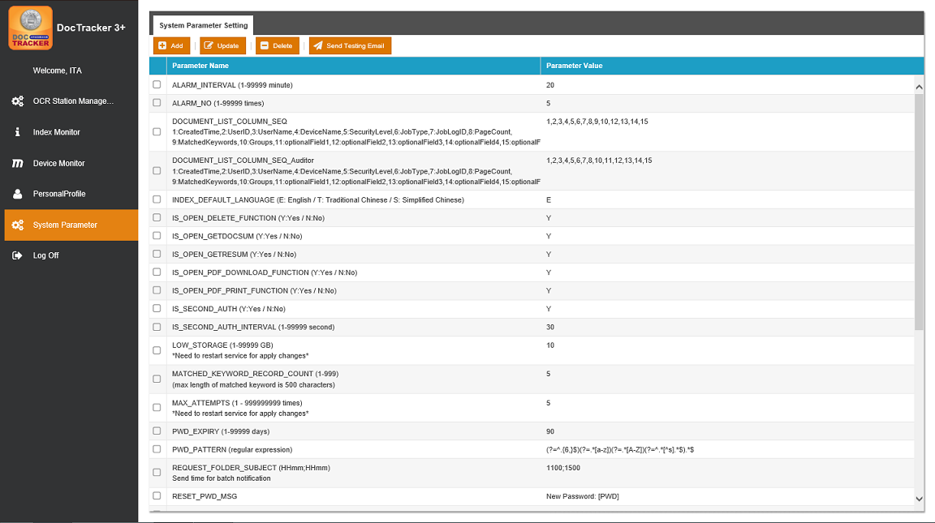

The functions of each System Default Parameter are listed below

|  |  |
| --- | --- |
| Default Parameter Name | Description / Function |
| ALARM_INTERVAL | When OCR Server is disconnected, the time interval (in min) that DocTracker sends email alert. |
| ALARM_NO | When OCR Server is disconnected, the number of time that DocTracker sends email alert. |
| INDEX_DEFAULT_LANGUAGE | The default language for the index login page. Set value E for English / T for Traditional Chinese and S for Simplified Chinese. |
| IS_OPEN_DELETE_FUNCTION | Define turn on or turn off the delete document function for the reviewer. Set value Y for Yes and N for No. |
| IS_OPEN_PDF_DOWNLOAD_FUNCTION | Define turn on or turn off the download document function. Set value Y for Yes and N for No. |
| IS_OPEN_PDF_PRINT_FUNCTION | Define turn on or turn off the print document function. Set value Y for Yes and N for No. |
| IS_SECOND_AUTH | Determine whether a second user is required to login when a user views a document. Set the value to Y to apply. |
| IS_SECOND_AUTH_INTERVAL | Set the time interval (in sec) allowing the authentication of the second user to keep in the section. |
| LOW_STORAGE  (*Need to restart the service in order to apply any changes) | Set the storage size (in GB) for the system to send an email notification when the storage size of the DocTracker server is running low. |
| MATCHED_KEYWORD_RECORD_COUNT | Set the number of sensitive keyword that the system able to count in a single document. |
| MAX_ATTEMPTS  (*Need to restart the service in order to apply any changes) | Set the number of time a user is able to attempt to login before the system lock the user out. |
| PWD_EXPIRY | The number of day when the password will be expired. Default is 90 days. |
| PWD_PATTERN | Define password complexity. Natural Language Express should be used. |
| REQUEST_FOLDER_SUBJECT | Set the time which an email notification email will be sent by batch mode when a sensitive keyword triggered |
| RESET_PWD_MSG | Reset password email content. |
| RESET_PWD_SUBJECT | Reset password email subject. |
| SEARCH_ENGINE_PATH | Search engine location |
| SEND_LINK_MSG | Document notification email content. |
| SEND_LINK_MSG_NO | The number of document in a single email |
| SEND_LINK_SUBJECT | Document notification email subject |
| SERVER_PATH | DocTracker server IP address |
| SMTP_HOST | SMTP server name or address |
| SMTP_IS_SSL | If SMTP connection requires SSL, set the value to Y |
| SMTP_PORT | SMTP server port |
| SMTP_PWD | User password that is used to connect to SMTP |
| SMTP_USER_NAME | Username that is used to connect to SMTP |
| SYSTEM_EMAIL | Notification email sender |
| WATERMARK_TYPE | The watermark type for view document (F: Filled / D: Diagonal) |

### Add System Parameter

1. To add a new parameter, click the  button to the following screen will pop up:

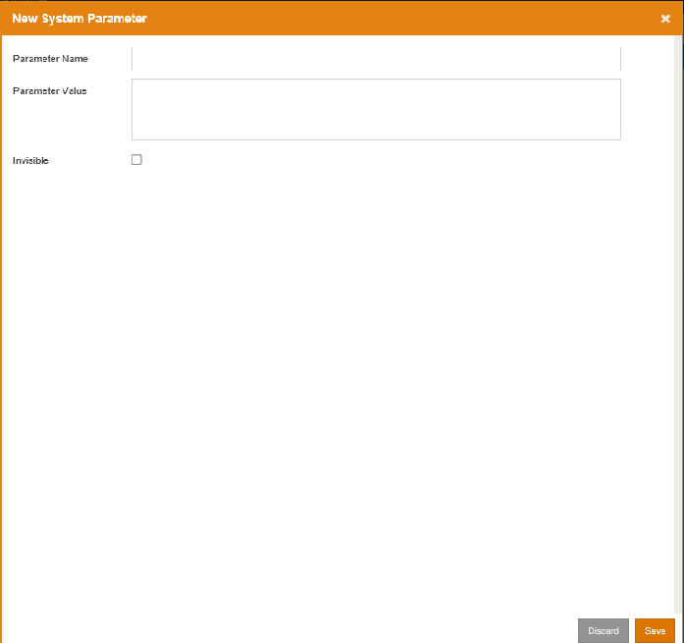

The description of each field is listed below:

|  |  |
| --- | --- |
| Field | Description |
| Parameter Name | Unique name for the system parameter |
| Parameter Value | Information for the system parameter |
| Invisible |  |

### 1.1.2 Update System Parameter

To update system parameter, select the parameter and click the  button or double click the parameter to bring up the following update parameter screen:

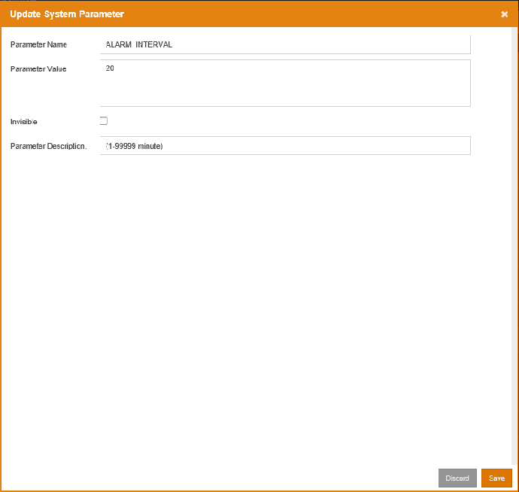

Once the modification is made, click the  button to save the changes. Click the  button to exit the screen without saving.

### Delete System Parameter

To delete a parameter, select the parameter and click the  button. A confirmation message will prompt the user to confirm the deletion of the parameter as below:

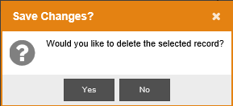

Click  button to delete the parameter or click  button to cancel the deletion.

### Send Testing Email

To check whether the SMTP settings are correct, press the  button to send a testing email to the Technician user.

# Supervisor

## OCR Station Management

To define OCR server, click OCR Station Management on the navigation bar, and the following screen will show. At the OCR Station Setting tab, Technician can define OCR Station ID, IP address, Port, and interval time, etc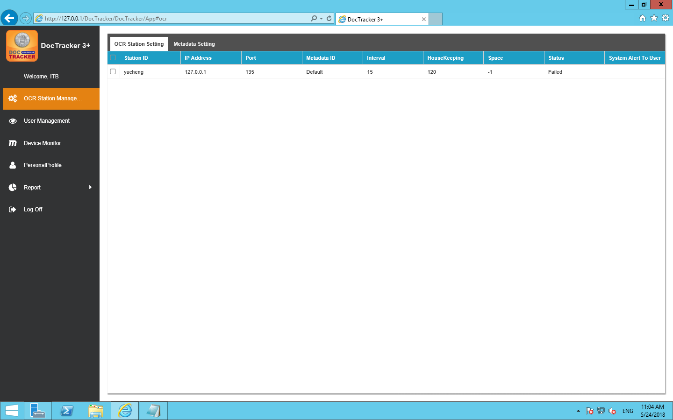

The functions of each field are listed below:

|  |  |
| --- | --- |
| Field / Button | Description / Function |
| Station ID | OCR server unique name |
| IP Address | OCR server IP address |
| Port | OCR server platform’s connection port |
| Metadata ID | Metadata to be used in the OCR server |
| Interval | The interval time (in minute) to monitor the specific folder for OCR server. |
| HouseKeeping | The time period (in month) to keep the information in the OCR server |
| Space | Available space (in GB) in OCR server |
| Status | The connection status between the DocTracker server and the OCR server |
| System Alert to User | If OCR server is disconnected, specified DocTracker user will receive an email notification |

## 用戶管理

Once login with Supervisor role, DocTracker main page will show User Account Summary as below:

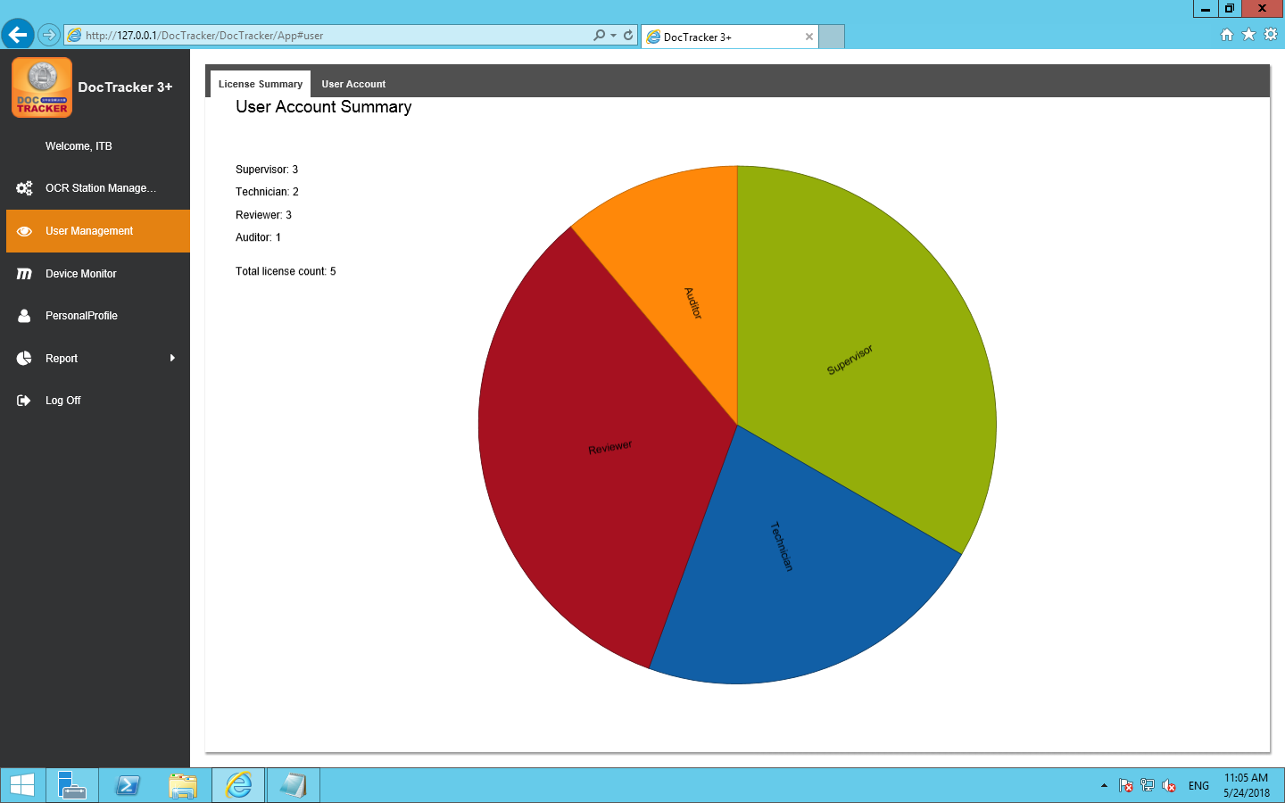

### New User

Before setting up and starting to use the DocTracker, you need to create user accounts for different roles. The Admin role can create accounts for the (Supervisor, Technician) role, and the Supervisor role can create accounts for the (Auditor, Reviewer) role. To add a new user, go to the  tab, click the  button, and the following screen will pop up:

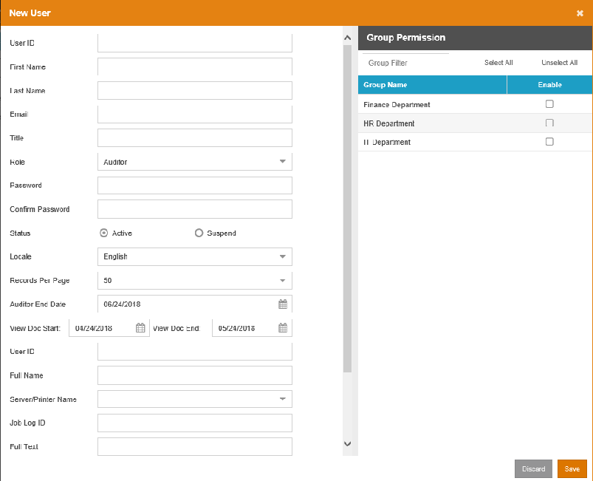

The functions of each field and button are listed below:

|  |  |
| --- | --- |
| Field / Button | Description / Function |
| User ID | The unique Login ID for the user. |
| First Name | The first name of the user. |
| Last Name | The last name of the user. |
| Email | The email address of the user. |
| Title | The title of the user. This can be blanked. |
| Role | The Technician user has permission to setup the system. The Supervisor user has permission to create Reviewer and Auditor. |
| Password | The password for the user. |
| Confirm Password | Re-type the password for the user. |
| Status | The status of the user. “Active” enables the user to logon to the system. “Suspend” disables the user to access the system. |
| Locale | The language for the User Interface. It can be “English”, “Simplified Chinese” or “Traditional Chinese”. |
| Records Per Page | The number of records shown on each page. The value ranges from 10 to 60. |
|  | Press this button to leave this page without adding the user. |
|  | Press this button to create the user with the input information. |

### User Info Update

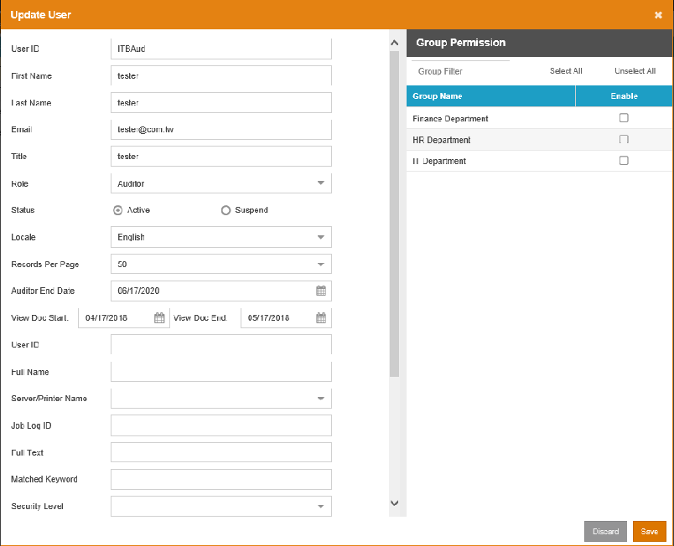

### Delete User Account

1. To delete a user, select the user and click the  button. A confirmation message will prompt the user to confirm the deletion of the user as below 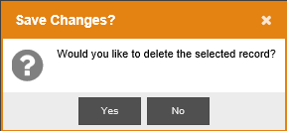
2. Click  to delete the user or click  to cancel the deletion.

### Reset Password Reset

To reset password of a specific user, select the user and click the  button to bring up the following [Reset User Password]screen:

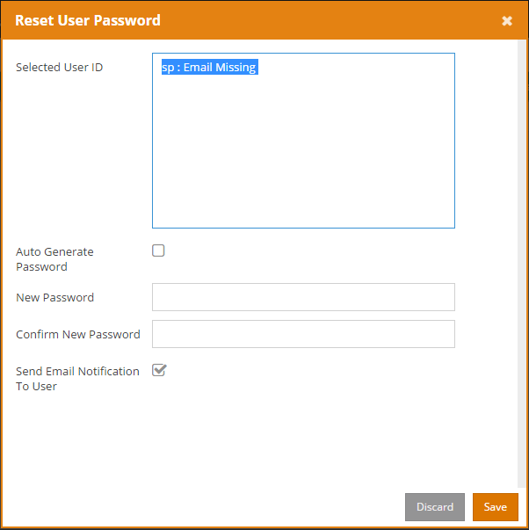

Click the  button to reset. Click the  button to exit the screen without resetting the password.

The following table describes the fields in the [Reset User Password] screen:

|  |  |
| --- | --- |
| Field | Description |
| Selected User ID | The user which is currently selected, and states if the user has an email address |
| Auto Generate Password | Auto generates a password and sends to this user via email. |
| New Password | Customize a password for this user. |
| Confirm New Password | Re-enter the password. |
| Send Email Notification To User | Specify whether to send email to this user. |

### View Group (except MFP)

To view Access Map User Mapping for Access Map Permission, or to view AD OU Mapping for AD / OU Permission, click the  button to view the groups and their users.

## Device Monitor

The Device Monitor displays the number of printed documents, the number of copied documents, the number of scanned documents, and the number of faxed documents.

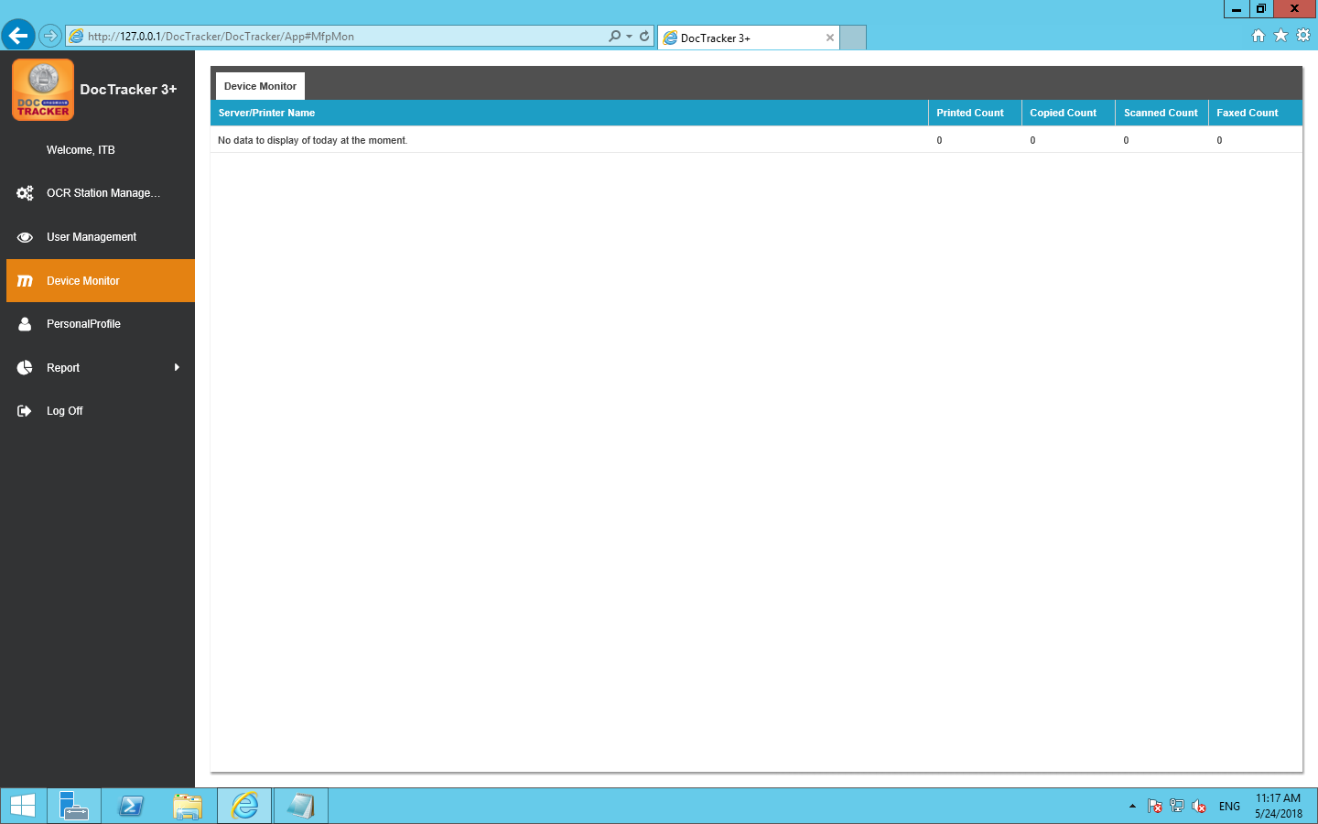

## Personal Profile

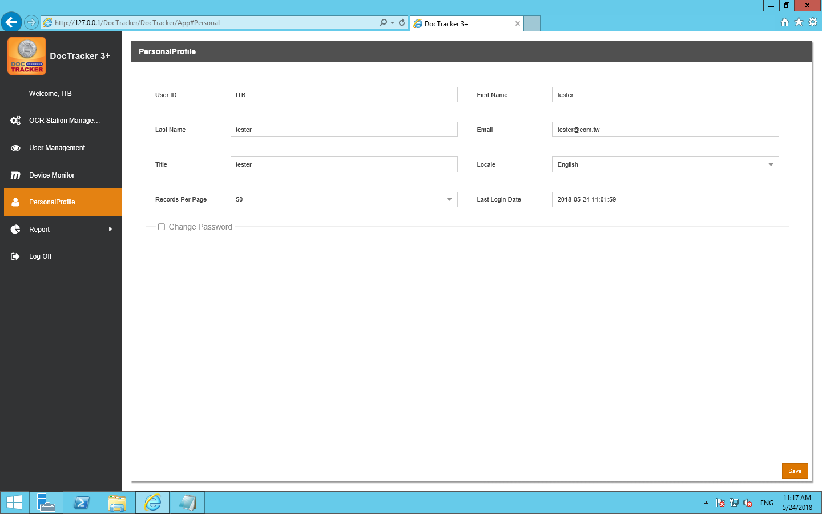

It shows user information about [User ID] [First Name] [Last Name] [Email] [Title] [Locale][Records Per Page][Last Login Date], language can be adjusted by [Locale].

In addition to the [User ID] can not be changed, other information can be changed

Press after change and a following screen will pop up:



The new setting will take effect after the next login.

## Report

### Report

To create different types of system report, click Report button under the Report in the navigation bar, and the following screen will pop up: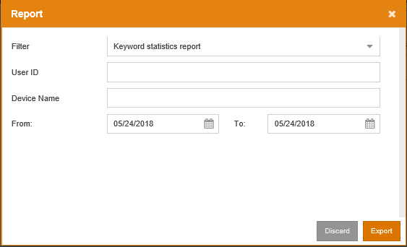

### Audit Trail

DocTracker records the activity of every document. None of the DocTracker users are able to modify or delete any entries in Audit Trail. To view the audit trail, click the Audit Trail under Report in the navigation bar, and the following screen will be shown: 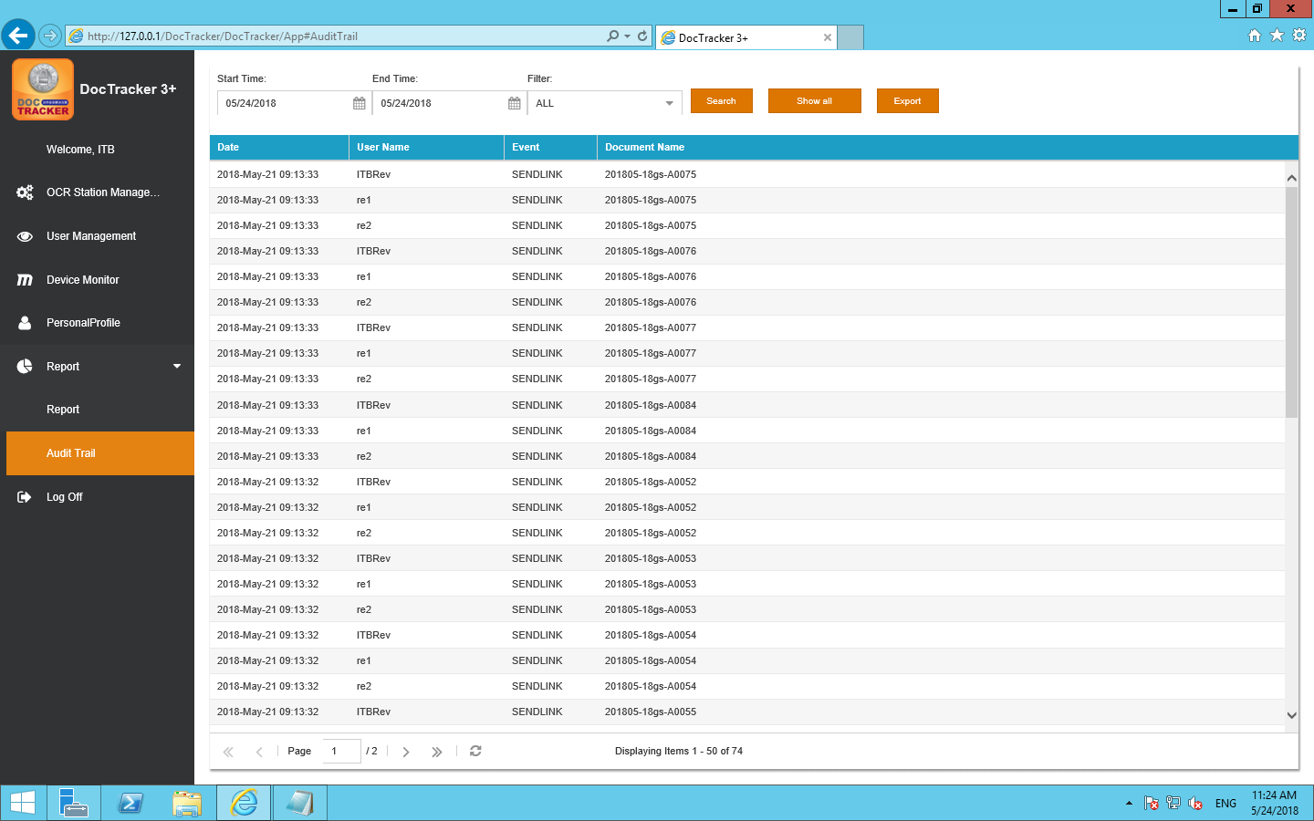

|  |  |
| --- | --- |
| Field / Button | Description / Function |
| Start Time | The beginning date of the search |
| End Time | The end date of the search |
| Filter | Display the specific event of the audit trail, which includes, All, Browse, Delete, and Send Link |
|  | Click this button to perform the search with selected criteria |
|  | Click this button to display all the activities that occurred in the system |
|  | Click this button to export the audit trail as excel file |

# Auitor

## Dashboard

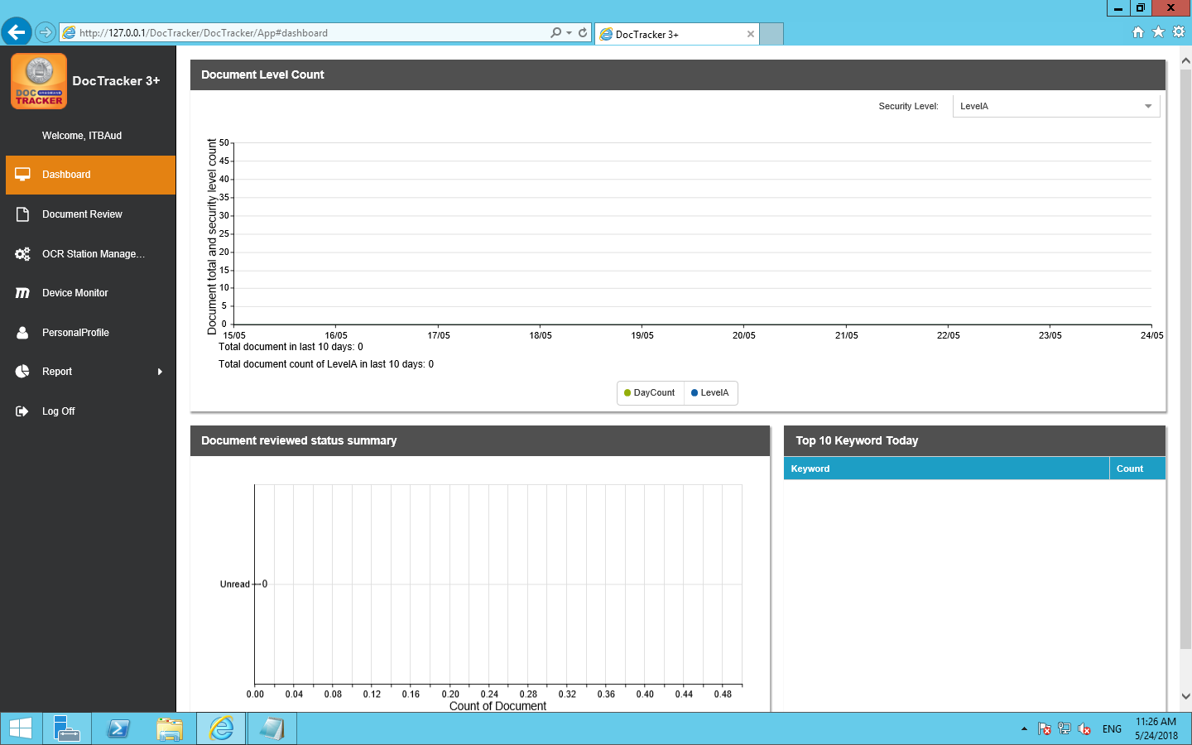

### View Settings

Set up a drop-down menu on the screen 

Set different security levels for viewing, Viewable items:

1.Document total security level count

2.Document reviewed status summary

3.Top 10 Keyword Today

## OCR Station Management

To define OCR server, click OCR Station Management on the navigation bar, and the following screen will show. At the OCR Station Setting tab, Technician can define OCR Station ID, IP address, Port, and interval time, etc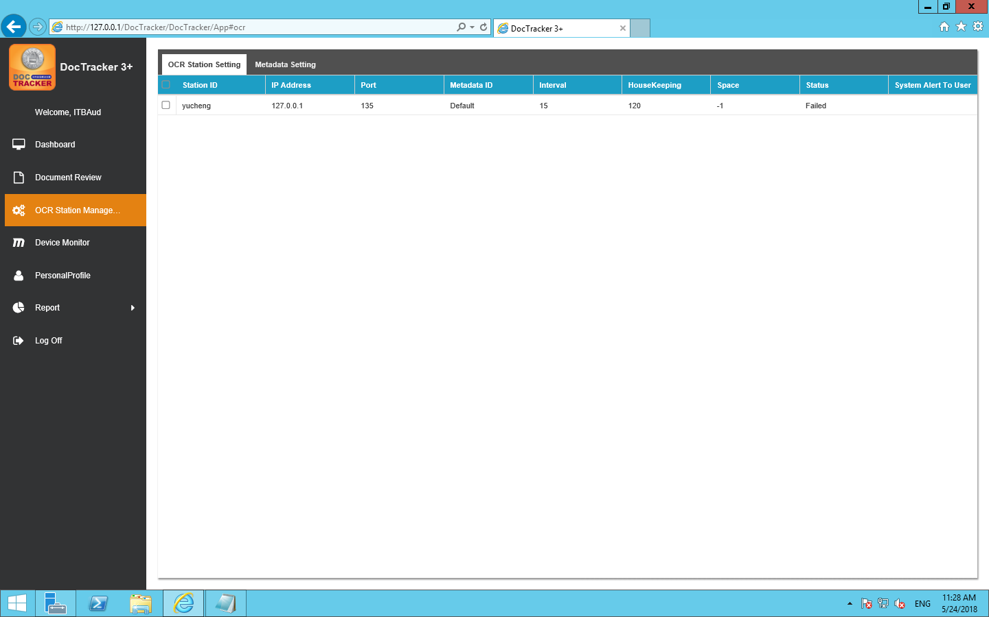

The description of each fields are listed below:

|  |  |
| --- | --- |
| Field / Button | Description / Function |
| Station ID | OCR server unique name |
| IP Address | OCR server IP address |
| Port | OCR server platform’s connection port |
| Metadata ID | Metadata to be used in the OCR server |
| Interval | The interval time (in minute) to monitor the specific folder for OCR server. |
| HouseKeeping | The time period (in month) to keep the information in the OCR server |
| Space | Available space (in GB) in OCR server |
| Status | The connection status between the DocTracker server and the OCR server |
| System Alert to User | If OCR server is disconnected, specified DocTracker user will receive an email notification |

## Document Review

DocTracker supports dual authentication when a user views a document. Before viewing a document, authentication of two users is required. After clicking Document Review in the navigation bar, documents that are created on that day will be listed as below. Users can select any dates to view the documents of that day. 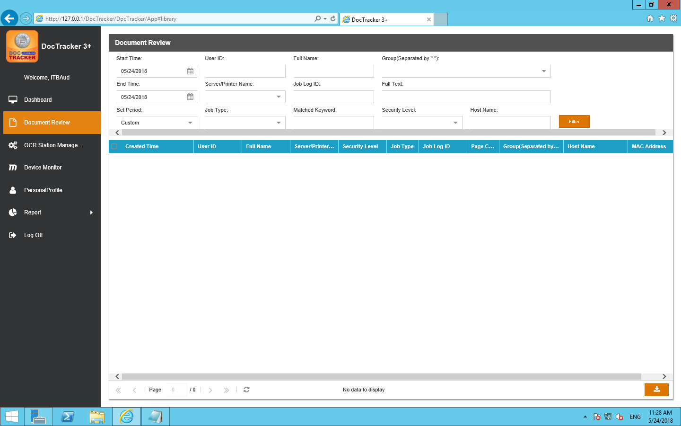

## Device Monitor

The Device Monitor displays the number of printed documents ,the numbers of copied document ,the number of scanned documents ,and the numbers of faxed documents.

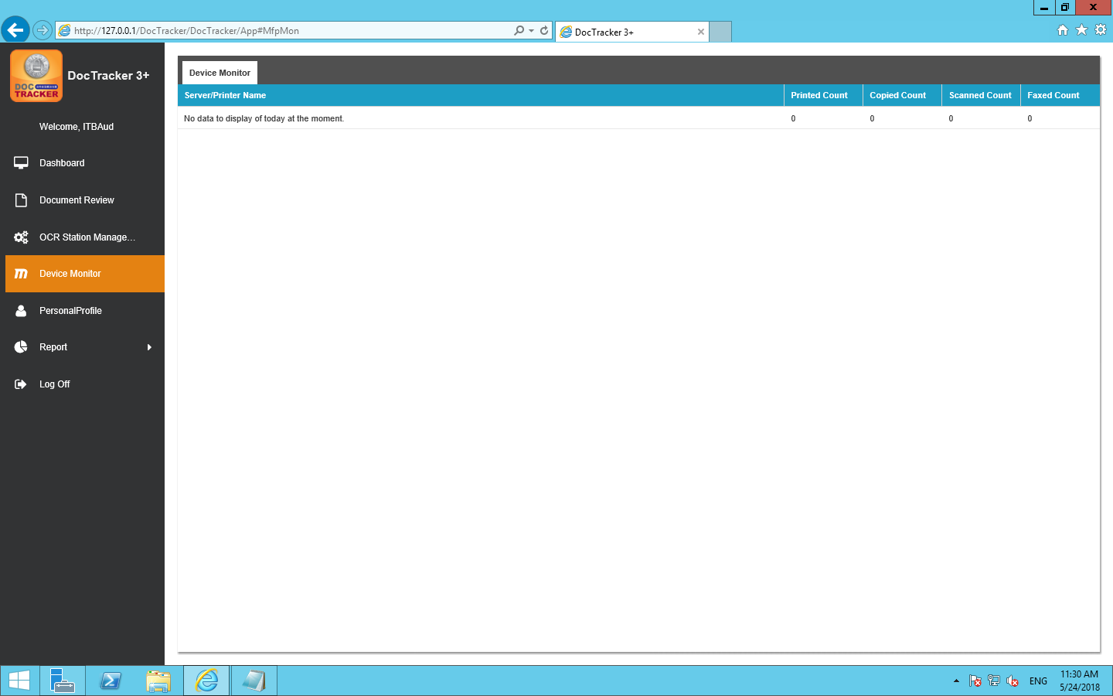

## Personal Profile

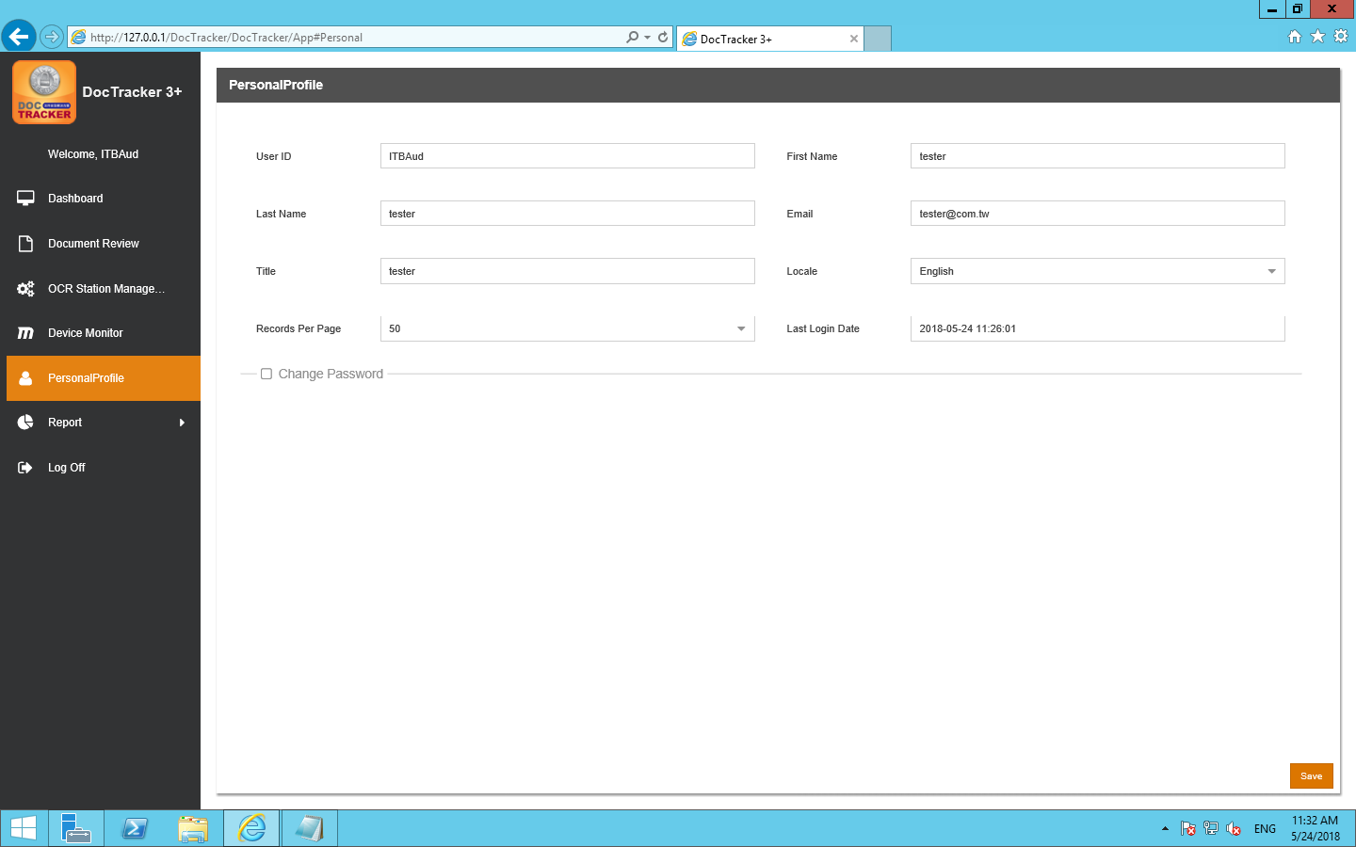

It shows user information about [User ID] [First Name] [Last Name] [Email] [Title] [Locale][Records Per Page][Last Login Date], language can be adjusted by [Locale].

In addition to the [User ID] can not be changed, other information can be changed

Press after change and a following message appears

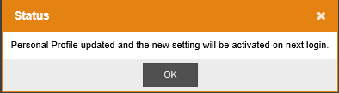

即新的設定會在下次登入後生效.

## Report

### Report

To create different types of system report, click Report button under the Report in the navigation bar, and the following screen will pop up: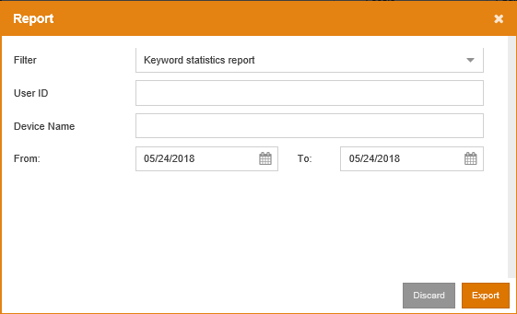

### Audit Trail

DocTracker records the activity of every document. None of the DocTracker users are able to modify or delete any entries in Audit Trail. To view the audit trail, click the Audit Trail under Report in the navigation bar, and the following screen will be shown: 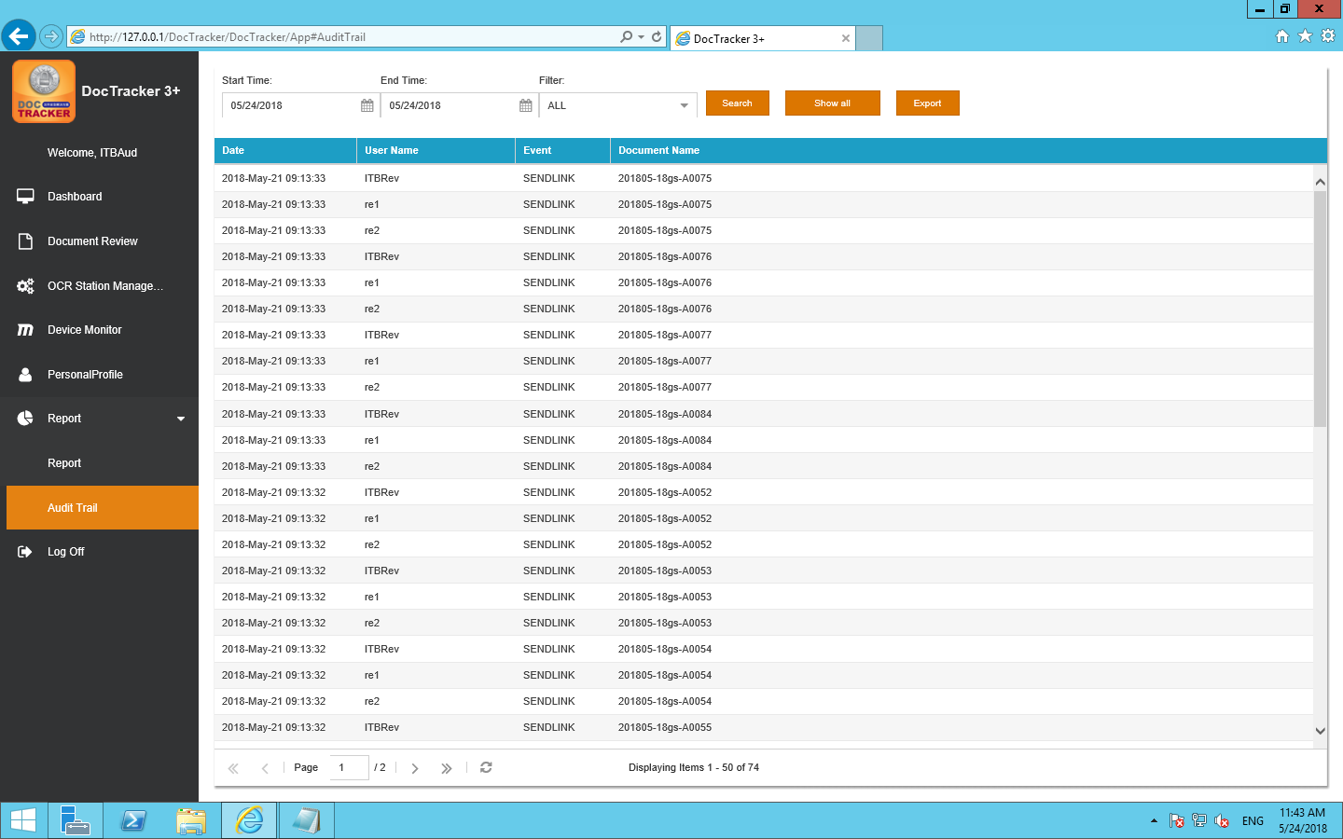

|  |  |
| --- | --- |
| Field / Button | Description / Function |
| Start Time | The beginning date of the search |
| End Time | The end date of the search |
| Filter | Display the specific event of the audit trail, which includes, All, Browse, Delete, and Send Link |
|  | Click this button to perform the search with selected criteria |
|  | Click this button to display all the activities that occurred in the system |
|  | Click this button to export the audit trail as excel file |

# Reviewer

## Dash Board

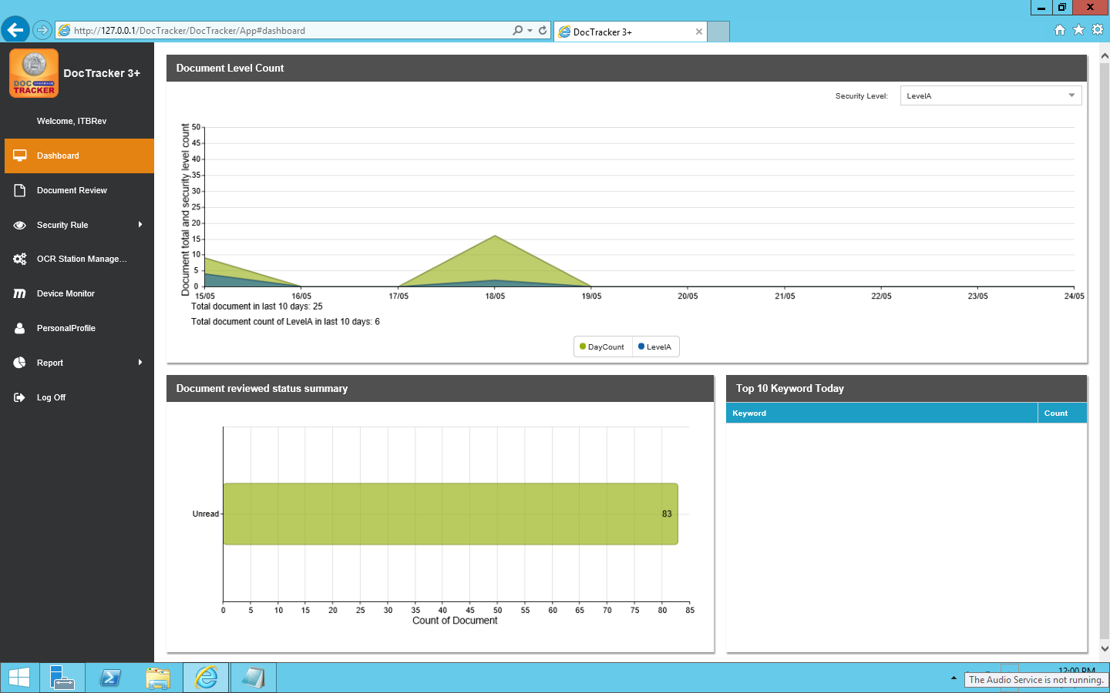

### View Setting

Set up a drop-down menu on the screen 

Set different security levels for viewing, Viewable items:

1.Document total security level count

2.Document reviewed status summary

3.Top 10 Keyword Today

## Document Review

DocTracker supports dual authentication when a user views a document. Before viewing a document, authentication of two users is required. After clicking Document Review in the navigation bar, documents that are created on that day will be listed as below. Users can select any dates to view the documents of that day.

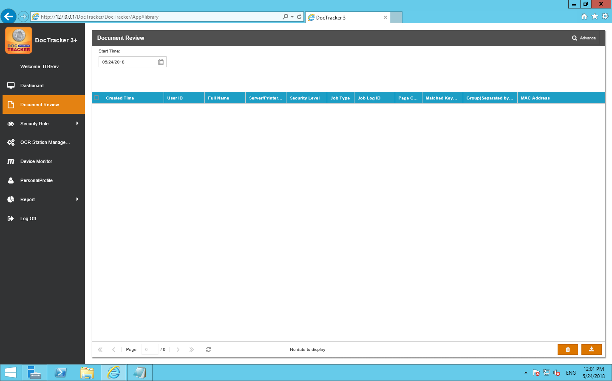

## Security Rule (Reviewer Only)

When DocTracker recognizes the sensitive keywords in the saved document, an email notification by default will be sent to the reviewer of that group.

### KeyWords

Click the Keyword under Security Rules in the navigation bar will show the following screen:

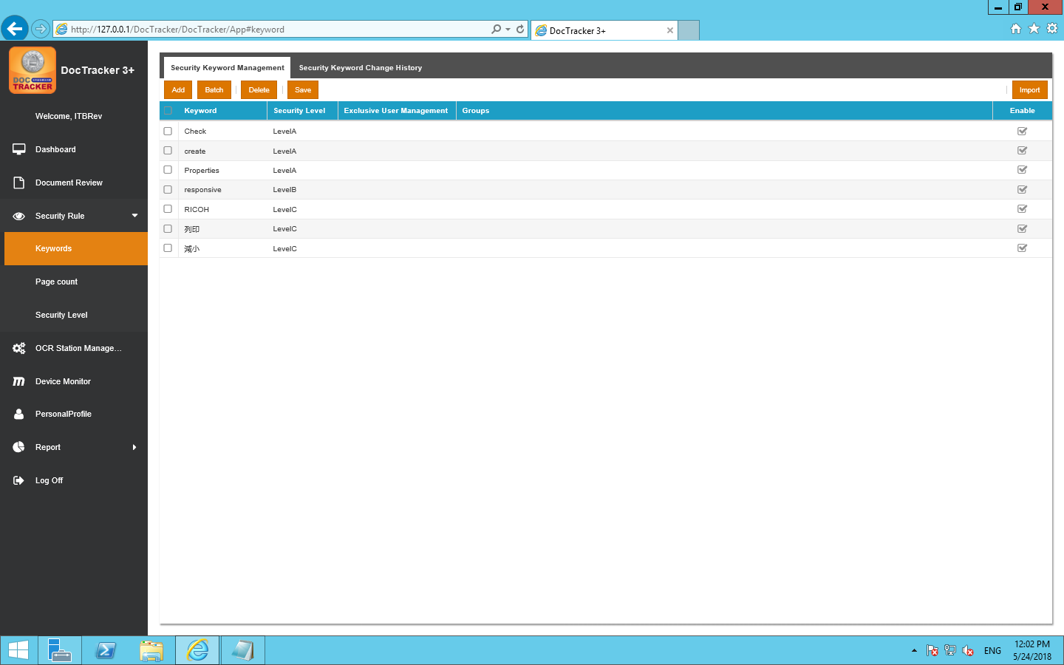

### Add New Keyword

To add a new keyword, click the button and a new entry will be created.

The description of each field are listed below:

|  |  |
| --- | --- |
| Field | Description |
| Keyword | Sensitive keyword of any languages.  Click to modify the keyword.。 |
| Security Level | Security Level of the sensitive keyword.  Default Levels are A,B,and C. |
| Exclusive User Management | The document that is uploaded by the exclusive user will be ignored |
| Groups | Only the document that is uploaded by the defined group will be recognize Double click to modify the groups. |
| Enable | Check this box to activate the keyword. |

### Batch Update

To batch update the keyword entries. Select desired entries to update and click

the button. and the following screen will pop up:

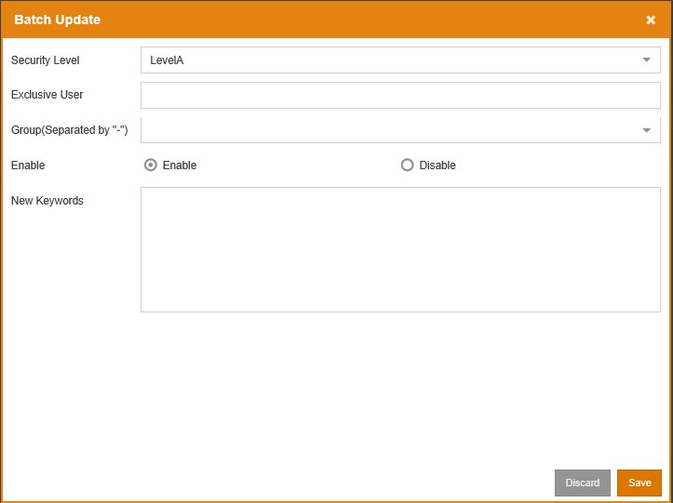

Once the modification is made, click the  to save the changes for all selected entries. Click the  to exit the screen without saving

### Delete Keyword

To delete keywords, select one or more entries and click the  button。

### Import Keyword

Keywords can be imported from a CSV file. To import, click the  button.

Browse the CSV file and click the  button.

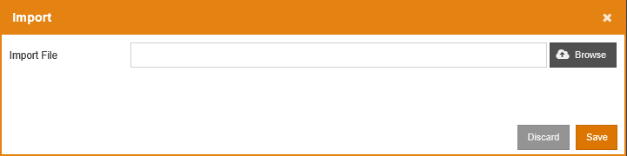

A confirmation message will pop up as below. Click  to import the keyword, or click  to cancel.

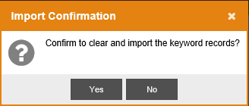

### Security Keyword Change History

To view the keyword history, click the  tab, and the following screen will be shown: 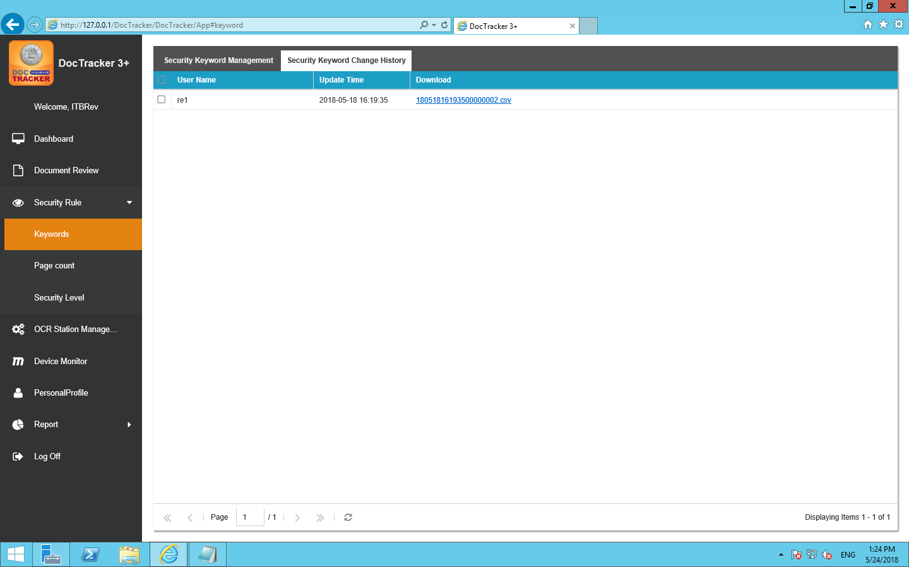

The descriptions of each field are listed below:

|  |  |
| --- | --- |
| Field | Description |
| User Name | The user who update the keyword |
| Update Time | The date and the time of the update |
| Download | Double click to download the CSV file of the keyword to your workstation |

**3.1.2數量(值)(功能未知)**

### Security Level

Sensitive keyword by default has three levels: A, B, and C. If a Level A sensitive keyword is found, an email notification will be sent immediately. If a Level B sensitive keyword is found, an email notification will be sent according to the defined time in the system setting. If a Level C sensitive keyword is found, no email notification will be sent. The default security levels cannot be modified.

Click the Security Level under Security Rules in the navigation bar will show the following screen: 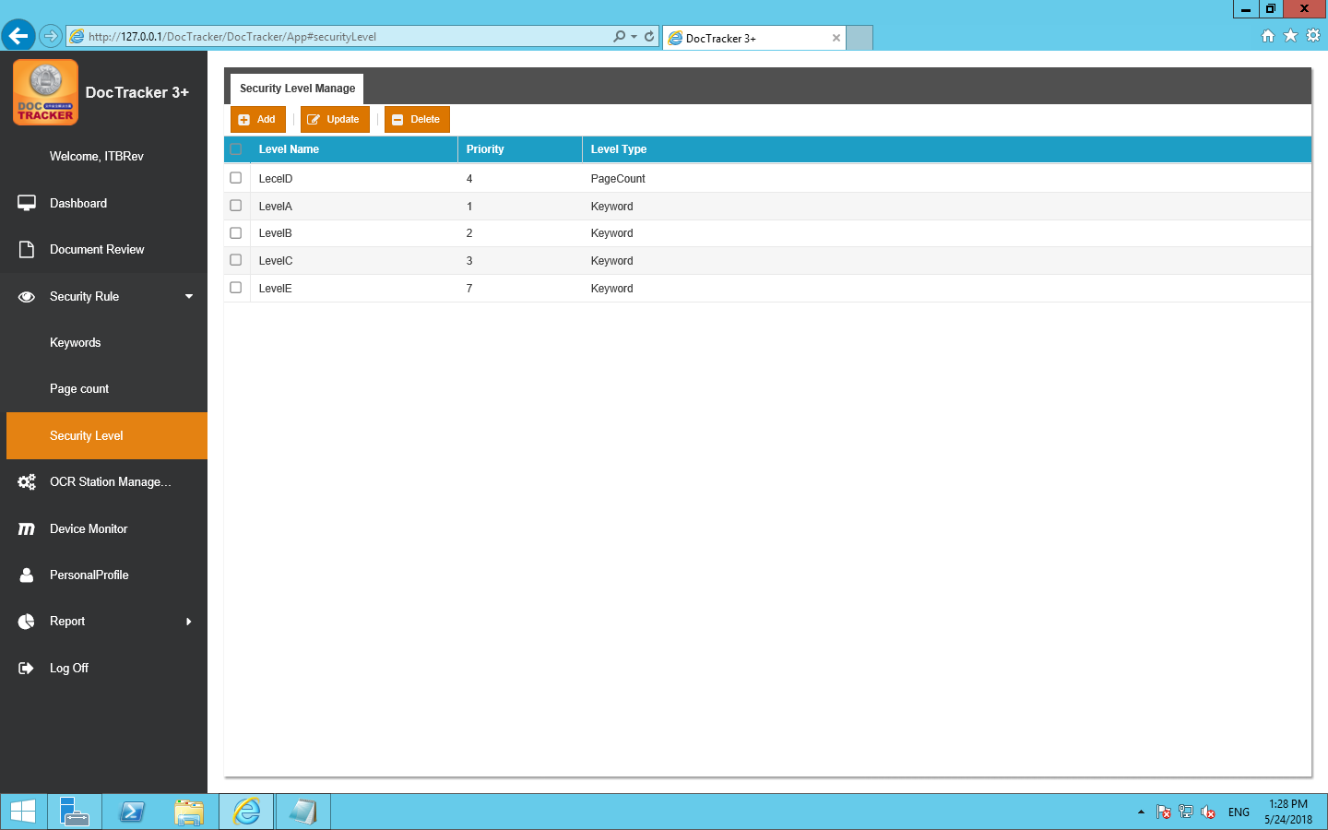

### Add New Security Level

To add a new security level, click the  button and the following screen will pop up:

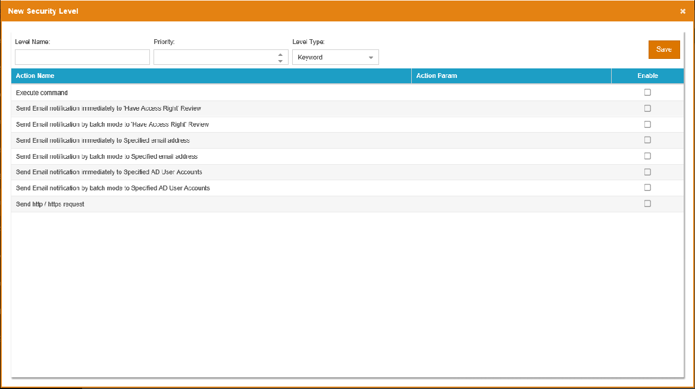

The functions of each field and button are listed below:

|  |  |
| --- | --- |
| Field / Button | Description / Function |
| Level Name | The unique name of the security level |
| Priority | The sequence of the security level for checking |
| Level Type | Only “Keyword” is useable currently |
|  | Press this button to create the security level |

### Update Security Level

To update a security level, select the security level and click the  button and the following screen will pop up: 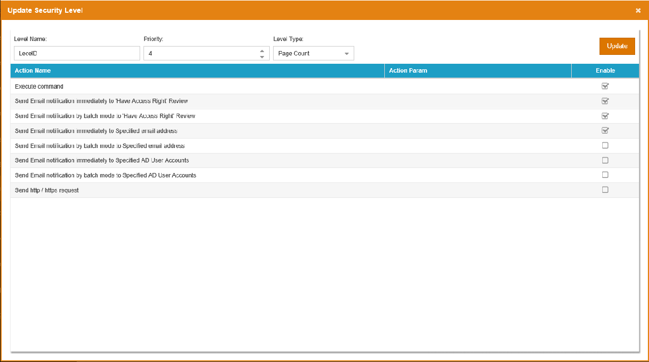

Once the modification is made, click the  button to save the changes.

### Delete Security Level

To delete security levels, select one or more entries and click the  button. A confirmation message will prompt the user to confirm the deletion of the security level as below.

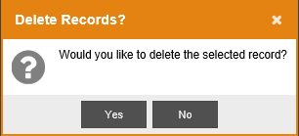

Click the  button to delete the security level or click the  button to cancel the deletion.

## OCR Station Management

To define OCR server, click OCR Station Management on the navigation bar, and the following screen will show. At the OCR Station Setting tab, Technician can define OCR Station ID, IP address, Port, and interval time, etc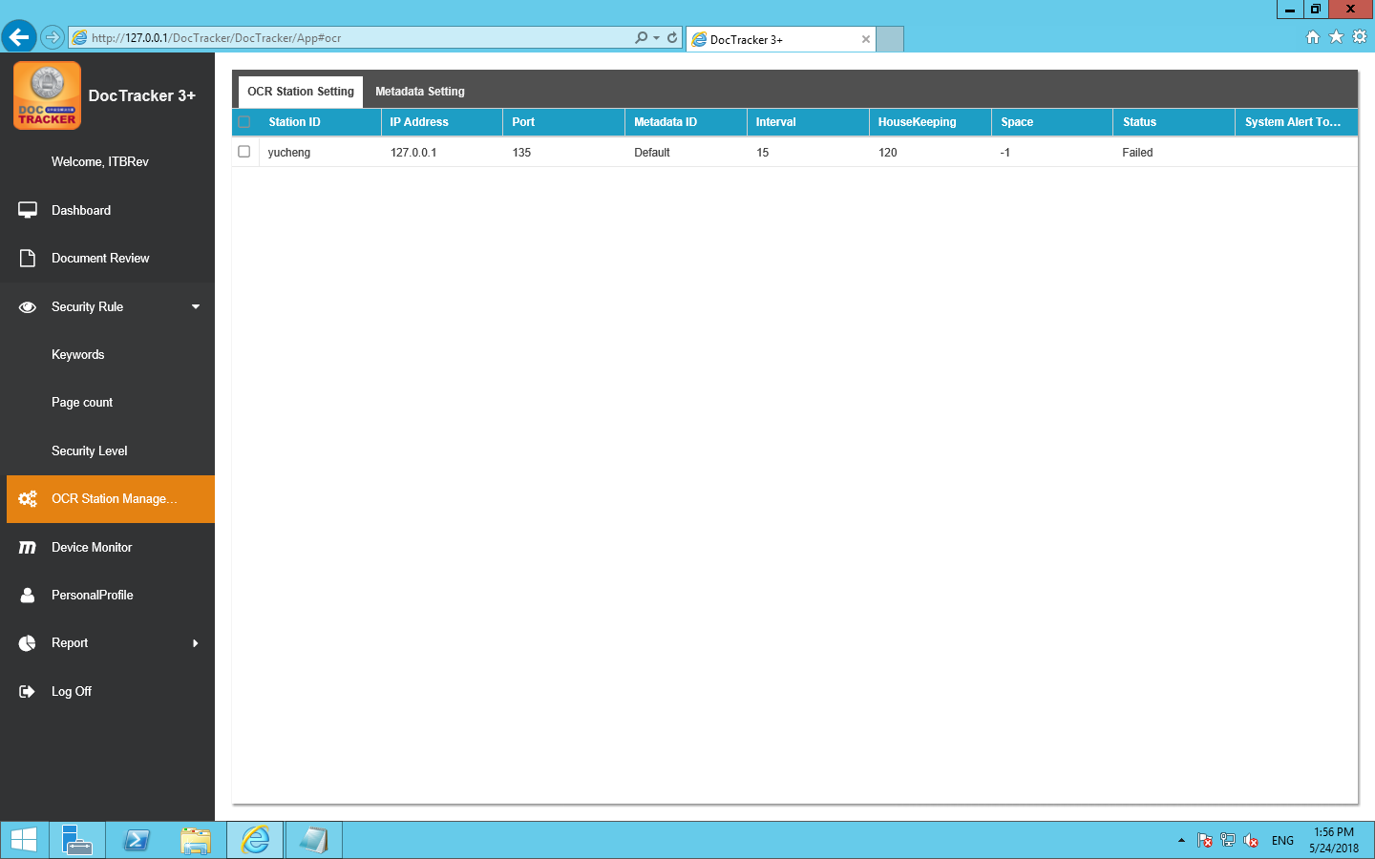

The description of each field are listed velow:

|  |  |
| --- | --- |
| Field / Button | Description / Function |
| Station ID | OCR server unique name |
| IP Address | OCR server IP address |
| Port | OCR server platform’s connection port |
| Metadata ID | Metadata to be used in the OCR server |
| Interval | The interval time (in minute) to monitor the specific folder for OCR server. |
| HouseKeeping | The time period (in month) to keep the information in the OCR server |
| Space | Available space (in GB) in OCR server |
| Status | The connection status between the DocTracker server and the OCR server |
| System Alert to User | If OCR server is disconnected, specified DocTracker user will receive an email notification |

## Device Monitor

The Device Monitor displays the number of printed documents, the number of copied documents, the number of scanned documents, and the number of faxed documents.

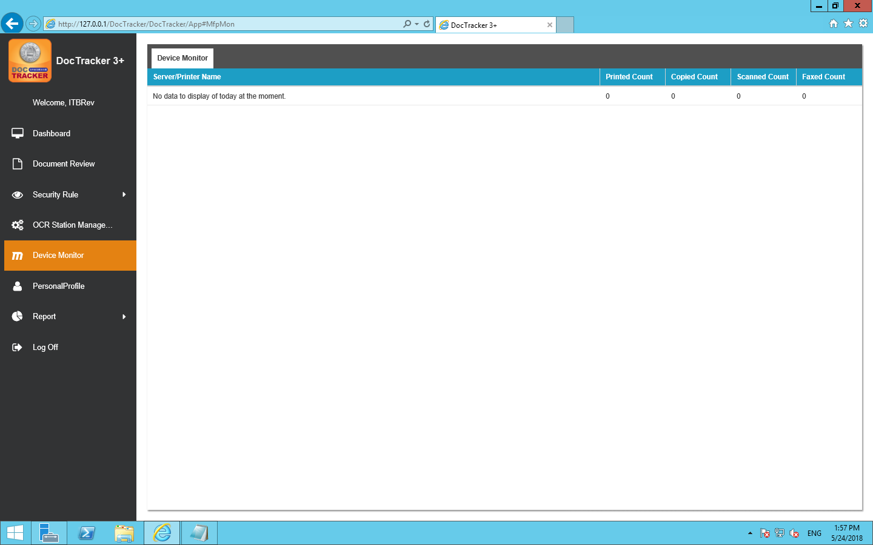

## Personal Profile

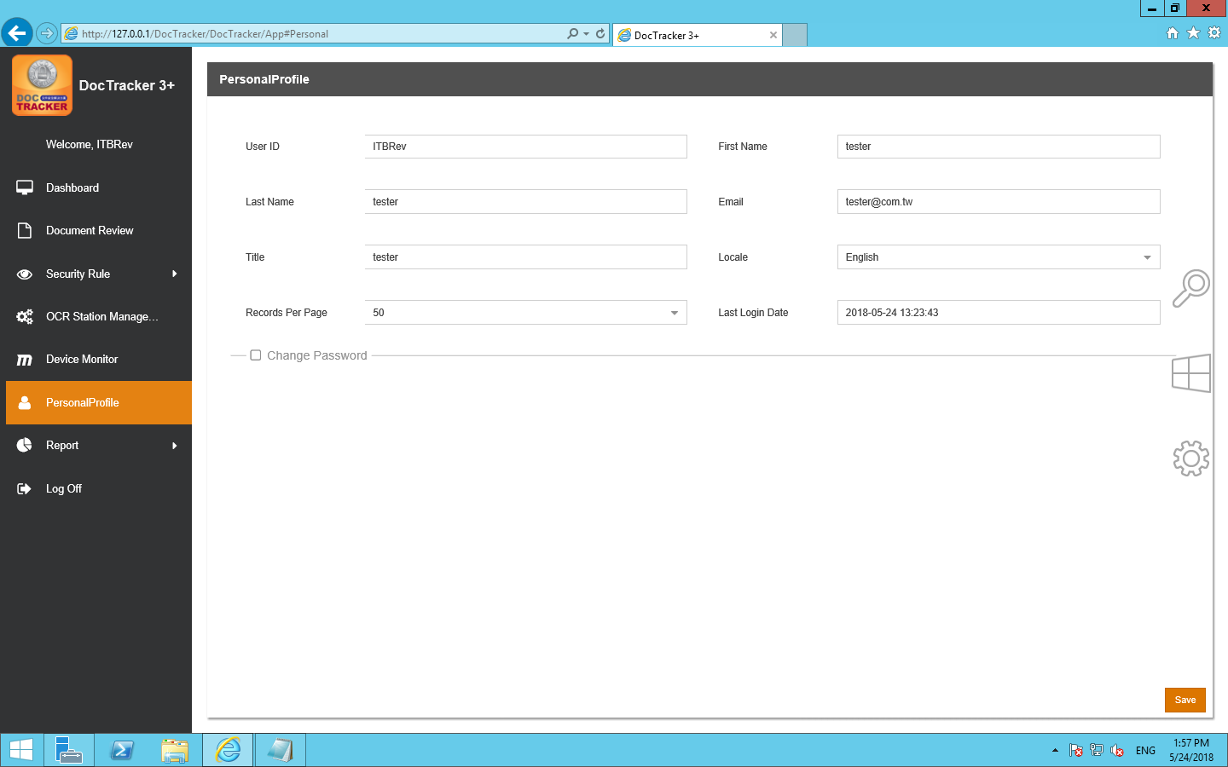

It shows user information about [User ID] [First Name] [Last Name] [Email] [Title] [Locale][Records Per Page][Last Login Date], language can be adjusted by [Locale].

In addition to the [User ID] can not be changed, other information can be changed

Press after change and a following message appears

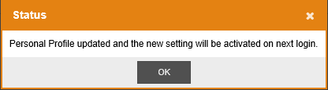

The new settings will be activated after the next login..

## Report

### Report

To create different types of system report, click Report under the Report in the navigation bar, and the following screen will pop up: 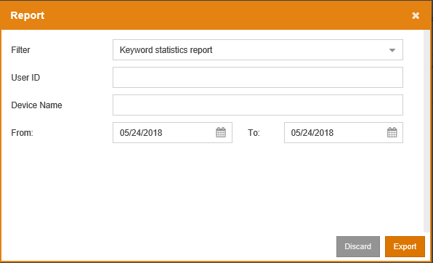

### 审计日志

DocTracker records the activity of every document. None of the DocTracker users are able to modify or delete any entries in Audit Trail. To view the audit trail, click the Audit Trail under Report in the navigation bar, and the following screen will be shown: 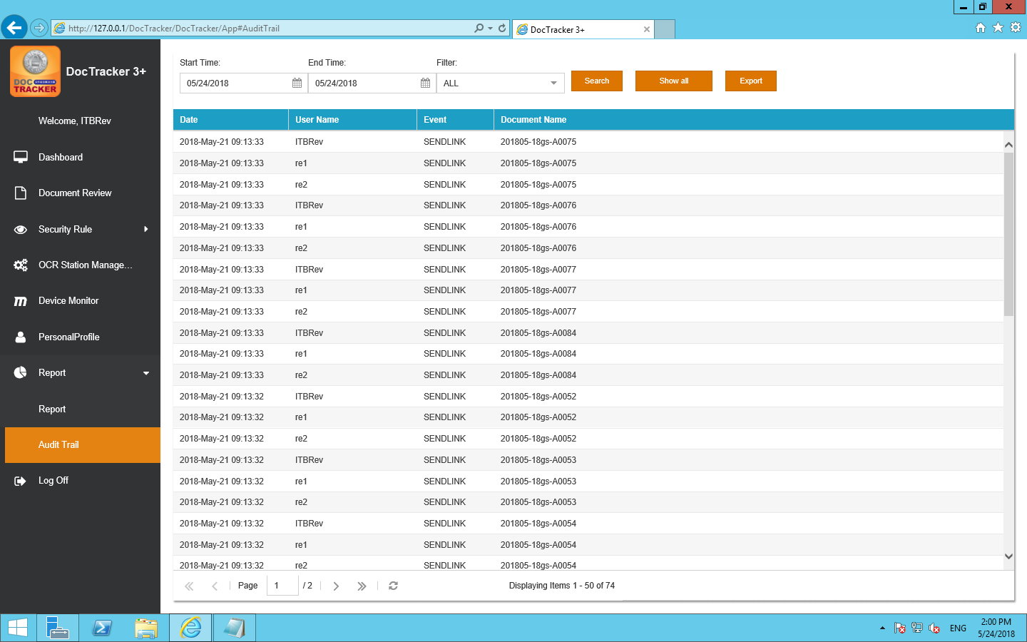

The functions of each field and button are listed below:

|  |  |
| --- | --- |
| Field / Button | Description / Function |
| Start Time | The beginning date of the search |
| End Time | The end date of the search |
| Filter | Display the specific event of the audit trail, which includes, All, Browse, Delete, and Send Link |
|  | Click this button to perform the search with selected criteria |
|  | Click this button to display all the activities that occurred in the system |
|  | Click this button to export the audit trail as excel file |